**Life Simulation – User’s and Developer’s Guide**

Bobby Chiang, Quincy Lam, Stephen Wen

**User’s Guide**

Background

A life simulation is a fun way to create your own worlds and see how they would play out. You can place life forms in an open, infinite world and watch the world evolve on its own. You can explore a world forever, the world will never end. Weather effects, terrain types, and many diverse life forms interact to create a new experience every time. Many life form interactions exist in this simulation, bunnies and cows eat grass, bats eat fruit, bears eat bunnies, cows and fruit.

Getting Started

When the game is run, using the provided .jar file, a full screen will open with a base map. Select points by clicking with the mouse and use the buttons at the bottom to place life forms in that location. The buttons at the bottom will add bears, bunnies, cattle, bats, trees, and grass as labelled. Clicking on the white rectangle surrounded by a blue border in the bottom right of the screen will open a log of what has happened so far in the simulation. Press escape to return to the simulation. Selecting the checkbox will cause the simulation to run with time, or you can advance the simulation one hour at a time by hitting the space bar. Use arrow keys to move up, down, left, right, and even diagonal to explore the world.

Features of the Program

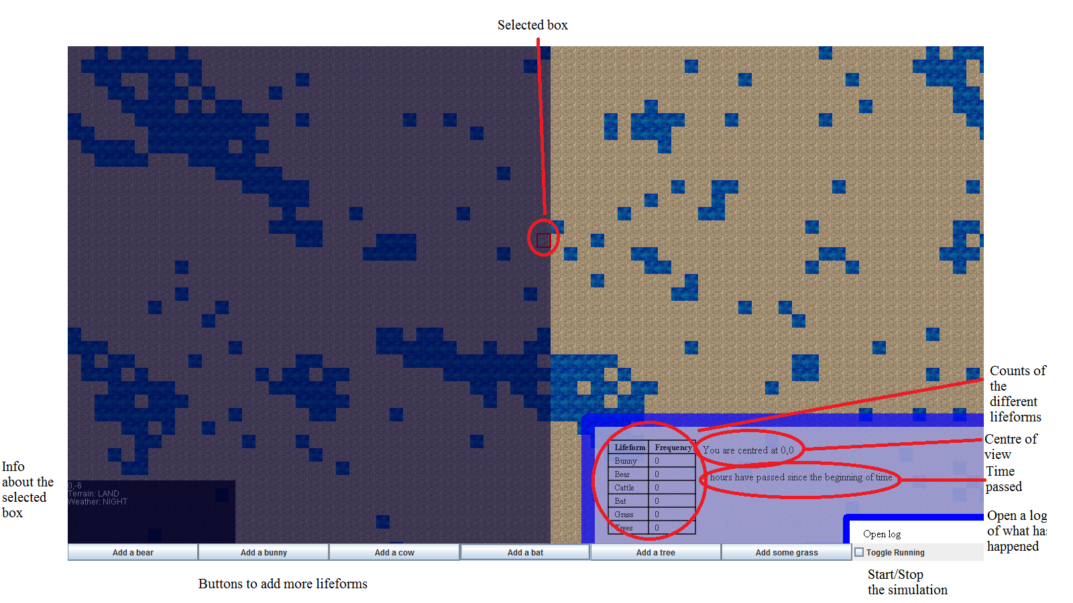

That screenshot is a typical start screenshot of the simulation. As shown, a point can be selected and that point will be surrounded by a red square. Information about that square will appear in the bottom left of the screen. Life forms can be added to the simulation at the selected point using the buttons at the bottom of the screen. The shaded region shows night, the lighter region is day. The blue tiles are water, the brown tiles are land.

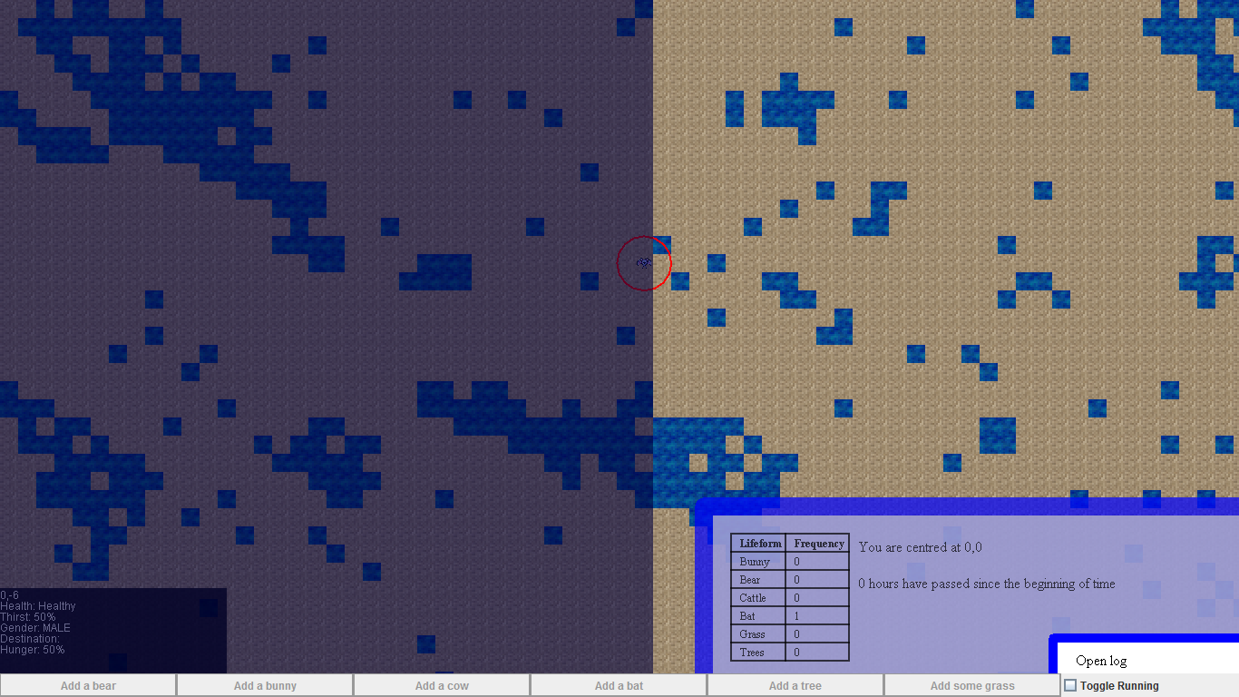

In this example, an animal has been selected. As seen in the bottom right corner, the information has changed. Now the information block in the bottom left shows information about the animal. This information includes location, diseased or healthy, thirst level, gender, destination, and hunger level.

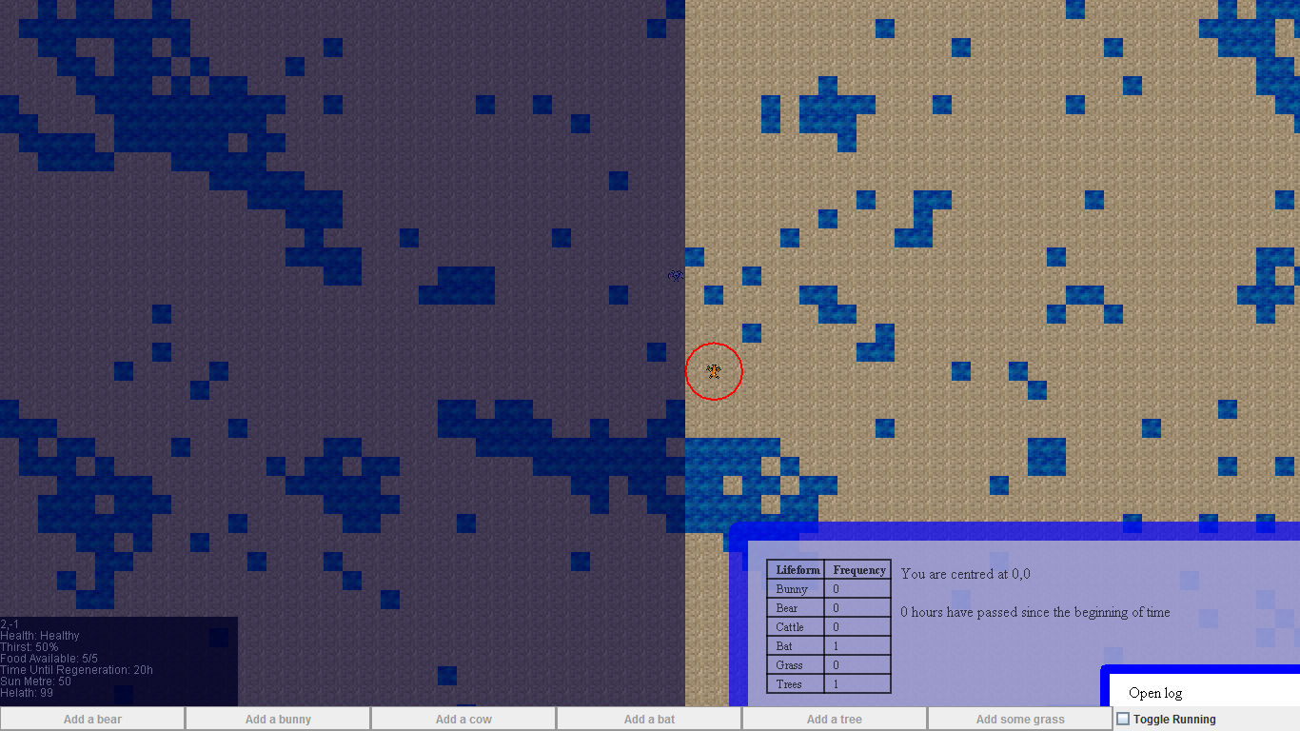

Here, a plant is selected.

Limitations and Bugs of the Program

Life forms are not completely intelligent, the memory of life forms was not fully implemented and animals walk around purely based on what is visible to them. Depravity was also not implemented and that would have caused life forms to act less and less logically.

**Developer’s Guide**

Overview

There are 21 classes divided into 4 packages that make up this program. There is the summative2013 package which holds driver classes for the program. There is the summative2013.lifeform package which contains all of the necessary classes to create and run life forms. There is the memory package which contains the incomplete classes that would be used to give life forms memory of where food was, who enemies are, etc. Finally, there is the phenomena package which contains weather and disease.

Sections of each Feature of the Program

**summative2013 Package**

This package contains two classes, the Summative class and the SpriteAssigner class. The Summative class is a driver class for the program. It is the panel that the simulation is drawn on, it stores where life forms are, it stores where the terrain is. The summative class also handles all input and gui elements. The SpriteAssigner class stores sprites for each life form.

**summative2013.lifeform Package**

This package contains the Lifeform class which is the parent class to all other life forms. It contains attributes like hunger, thirst, whether the life form is diseased, and other attributes common to all life forms. There is also the Animal class which is the parent class for all animal life forms. The Animal class contains attributes such as gender, direction of travel, group of friends, group of enemies and prey lists. The subclasses of Animal are Bear, Bunny, Cattle, and Bat. Bat is a special class as it is the only nocturnal animal in the simulation. The summative2013.lifeform package also contains the Vegetable class and all of its subclasses. This class describes plants. It contains data fields like regenTime which describes how long it takes for the plant to regain fruit. The subclasses of Vegetable are Tree and Grass.

**summative2013.phenomena Package**

This package contains the Weather and Disease classes. Weather describes what every type of weather needs, for example, the area that the weather covers. More specific weather attributes are described in the Drought, Drizzle, and AirLock classes. The Disease class describes a disease that an animal can have. It can hurt the animal.

**summative2013.memory Package**

This package contains the memories of animals. The Memory class describes a general memory, it can be forgotten or remembered. The SocietyMemory class remembers other life forms and how much a life form likes them. LocationMemory remembers what is in certain locations. AttributeMemory fills in any other type of memory

Suggestions for Improvement

Areas of further development include the full implementation of memory and depravity. Memory would make for interesting patterns by the animals, as they would return to similar areas in cyclical patterns. These areas would be generated every time the simulation is run. It would also allow for "gangs" to appear among animals. The memory of different life forms, within a species would allow for groups of life forms to stay together and kill life forms not in the group.

Depravity would allow for the simulation to show animals become more and more desperate. This could allow for the user to watch animals go crazy, and do things that would not normally happen. This could show the in-group and out-group deteriorating.